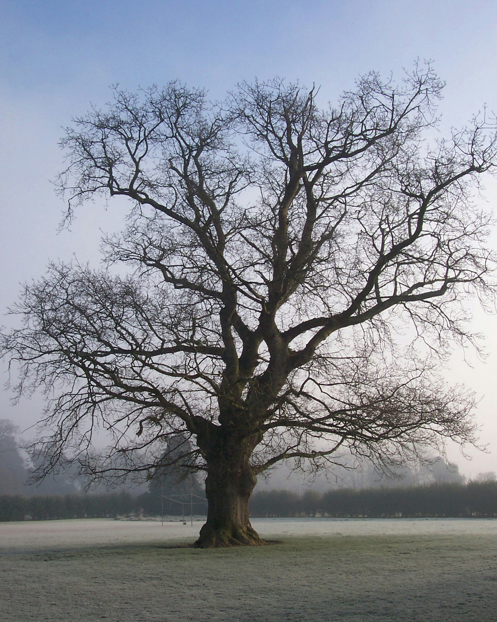
Scoil Náisiúnta Mhuire Chnoc a' Bhile

Dún Droma, Contae Thiobraid Árann.
Telefón: 062 71533. Ríomhphost/Email: knockavillans@gmail.com

Annual Admission Notice 2024
in respect of admissions to the 2024/2025 school year

A copy of the school’s Admission Policy and the Application form for Admission for the 2024-2025 school year is available as follows:

School website: www.knockavillans.ie

School Office: (062) 71533 and knockavillans@gmail.com

Write to: Scoil Mhuire Knockavilla, Dundrum, Co. Tipperary.

Application and Decision Dates for Admission to
2024/2025 School Year

The following are the dates applicable for admission to Junior Infants:

The school will commence accepting applications for admission on | 22.01.2024
The school shall cease accepting applications for admission on | 12.04.2024
The date by which applicants will be notified of the decision on their application is | 03.05.2024
The period within which applicants must confirm acceptance of an offer of admission is | 10.05.2024

*Failure to accept an offer within the prescribed period above may result in the offer being withdrawn
Note: the school will consider and issue decisions on late applications in accordance with the school’s admission policy.

Number of places available: 25

